10. Scenario: You are working on a data visualization project and need to create basic plots using

Matplotlib. You have a dataset containing the monthly sales data for a company, including the

month and corresponding sales values. Your task is to develop a Python program that generates line

plots and bar plots to visualize the sales data.

Question:

1. How would you develop a Python program to create a line plot of the monthly sales data?

2: How would you develop a Python program to create a bar plot of the monthly sales data?

Code:

import pandas as pd

import matplotlib.pyplot as plt

df = pd.read_csv(r"C:\Users\jampa\Downloads\monthly_sales_data.csv")

print("Columns in the DataFrame:", df.columns)

print(df.head())

df['Order Date'] = pd.to_datetime(df['Order Date'])

df['Month'] = df['Order Date'].dt.month_name()

monthly_sales = df.groupby('Month')['Quantity Sold'].sum().reset_index()

# 1. Line Plot of Monthly Sales

plt.figure(figsize=(10, 5))

plt.plot(monthly_sales['Month'], monthly_sales['Quantity Sold'], marker='o', color='b', linestyle='-', linewidth=2, markersize=6)

plt.title('Monthly Sales Data - Line Plot')

plt.xlabel('Month')

plt.ylabel('Quantity Sold')

plt.grid(True)

plt.xticks(rotation=45)

plt.tight_layout()

plt.show()

# 2. Bar Plot of Monthly Sales

plt.figure(figsize=(10, 5))

plt.bar(monthly_sales['Month'], monthly_sales['Quantity Sold'], color='c')

plt.title('Monthly Sales Data - Bar Plot')

plt.xlabel('Month')

plt.ylabel('Quantity Sold')

plt.xticks(rotation=45)

plt.tight_layout()

plt.show()

output:

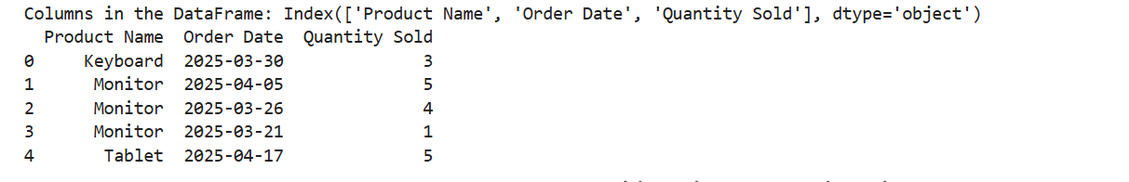

Dataset:

| **Month** | **Sales** |  |
| --- | --- | --- |
| January | 35000 |  |
| February | 42000 |  |
| March | 39000 |  |
| April | 45000 |  |
| May | 47000 |  |
| June | 48000 |  |
| July | 46000 |  |
| August | 50000 |  |
| September | 44000 |  |
| October | 41000 |  |
| November | 43000 |  |
| December | 46000 |  |